

LIMITED

LIABILITY COMPANY

**LASERTAG**

SPECEFICATION

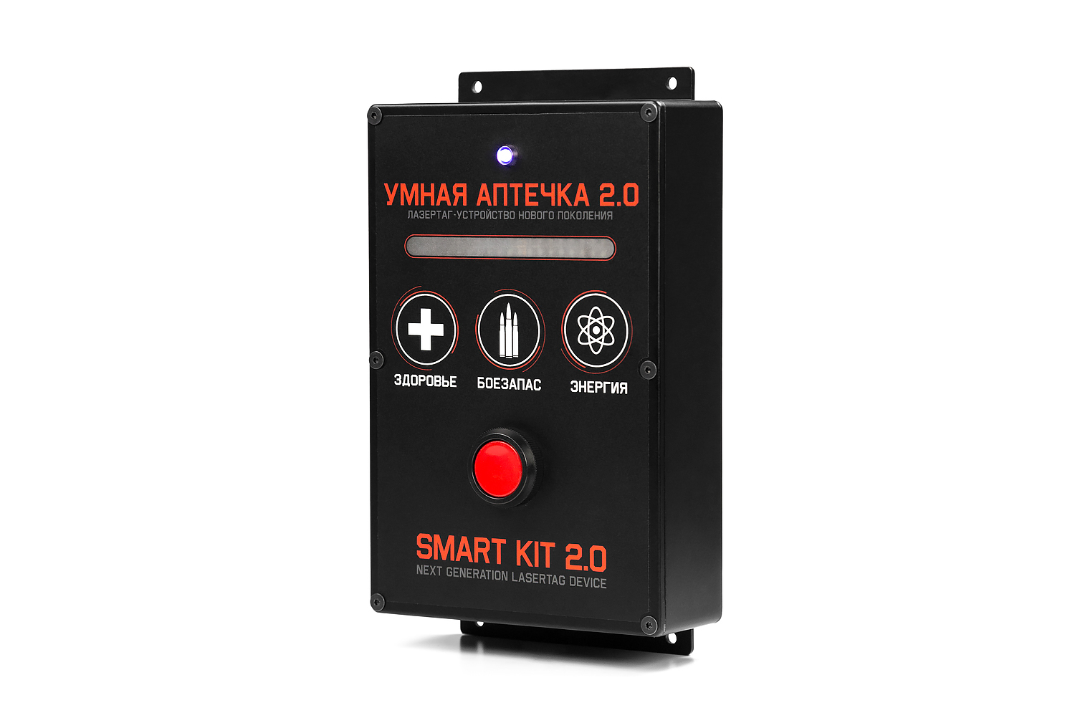

**Game set**

**Smart First aid kit 2.0**

Smolensk

1. **Contact information**

Official website:

www.laserwar.ru

E-mail:

info@laserwar.ru

support@laserwar.ru

Skype:

info-laserwar.ru

support laserwar.ru



**_____________________**

*Stamp signature*

In addition, during use of headbands, the device can experience mechanical damage to the caps that protect the sensors. In such cases, the caps must be replaced. It is necessary to recharge headbands immediately, no longer than 80 minutes after the game.

It is necessary to store the equipment in a well-ventilated space at temperature from + 18°C to + 30°C and relative humidity of 45-65%.

**Store equipment only in charged state (ideally under nominal voltage conditions).**

1. **Guarantee commitment**

The manufacturer guarantees the reliability of the operation of an individual LASERWAR set if the consumer has complied with the conditions of use. The manufacturer undertakes to replace or repair an individual set of equipment free of charge, if the customer has complied with the rules for the device transportation, storage, operation and delivery of defective equipment to Smolensk City.

**The warranty is 14 days for batteries, speakers, and IR modules.**

**PLEASE NOTE! In the case of improper operation of the accumulator (charging by an unrelated type of a charger), the warranty doesn't cover the battery!**

You can see on our website a complete technical maintenance manual for laser tag equipment: **www.cybertag.ru**.

Purchase Date: _______________

6

7

1. **Description and work**
   1. **Device**

The Smart first aid kit game set has a black color frame made of plastic.

Inside the frame there are batteries, clamping elements. On top of the frame there is a power button, RGB diode, sticker made of polyester film.

The Smart first aid kit 2.0 helps the players to recover health and replenish ammunition.

* 1. **Changing the performance characteristics**

Use the MILSIM configurator to change settings.

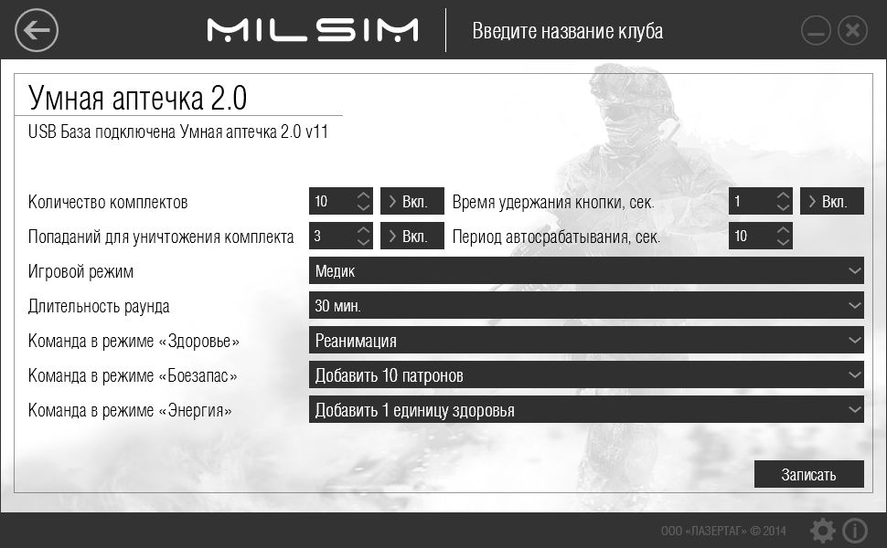

Information on the repairs performed during the maintenance period (completed by the Service centre performing the warranty repair works).

|  |  |
| --- | --- |
| **Date**: __________________  **Completed work:** _____________________________________________________________________  **Service centre stamp** | **Date**: __________________  **Completed work:** _____________________________________________________________________  **Service centre stamp** |
| **Date**: __________________  **Completed work:** _____________________________________________________________________  **Service centre stamp** | **Date**: __________________  **Completed work:** _____________________________________________________________________  **Service centre stamp** |
| **Date**: __________________  **Completed work:** _____________________________________________________________________  **Service centre stamp** | **Date**: __________________  **Completed work:** _____________________________________________________________________  **Service centre stamp** |

3

10

To run the programming mode, connect a USB base to the computer, and then run the MILSIM configurator. Place the device in the following way: the sensors of the base should be at a distance no more than one meter from the first aid kit. The sensors should face the scale of the device. Turn on the device. If you have already done that, use the "new game" command from the remote console. If you have connected the device in the right way, the RGB LED will light up purple, you will hear the signal three times. Having changed the settings press the "wtite" button.

* 1. **Pre-starting procedure**

You can turn on the Smart first aid kit 2.0 using a button located on the left side of the frame. Shortly press the activation button to choose a game mode, number of used sets. Hold the activation button to confirm your action.

Warranty Terms:

1. The guarantee is effective upon presentation of the present certificate, which indicates the purchase date of the equipment confirmed by the service centre.

2. These guarantee obligations apply to products acquired only from the official LASERTAG representative or the official dealer.

3. The present guarantee is invalid if the product deficiencies have occurred in the following cases:

- failure to comply with Operating instructions;

- mechanical damage;

- penetration of extraneous items, liquids, etc.;

- animal activities;

- unauthorized access to the parts of the game set by non-authorized persons;

- use of the product for purposes for which it hasn't been made;

- Acts of elements (natural disaster, fire, accidents, etc.);

- the game set malfunction in case of faulty power network and/or poor care of the product.

4. If the warranty certificate is lost, no duplicate is issued.

4

9



Dear Customer!

Our company welcomes and thanks you for the decision to buy our products, and is confident that the purchased device will bring you a long-term pleasure. The warranty certificate establishes the guarantee of the product in the amount provided for by the Law on consumer protection of the Russian Federation.

This warranty certificate is valid for **12 months** from the purchase date of the product, and is subject to the guarantee terms.

1. **Operating rules**

***1. Weather conditions.*** We strongly recommend that the equipment shouldn’t be used in the rain and at temperatures below -20°C. Avoid getting moisture inside the frame. If this happened, turn off the device, dry the equipment at room temperature for at least two hours.

Having used the device at low temperatures don't try to charge it immediately after the game. Wait for electronics to warm up.

***2. Batteries.*** The Smart first aid kit 2.0 has lead acid batteries. To recharge the device use only "Sonar" chargers.

**Connect the charger to the device, and only then to the network.**

You can control the recharge process with the help of a special indicator. If the battery is low, the LED is red; When the recharge process is complete, the color will be changed to green.

**Please note! The game set must be recharged immediately after you have played with it under constant supervision at temperature no less than 0°С and no longer than for 2 hours.**

***3. Headband*** When using headbands pay attention to hygienic cuffs. They will protect electronic parts from moisture. If the bandage gets wet, it can result in the electronics failure. That's why the bandage should be dried.

8

5

1. **The intent of the device**

The Smart first aid kit 2.0 game set is an additional device designed to play laser tag.

1. **Technical Specifications**

|  |  |
| --- | --- |
| Weight | 0.895 kg |
| Dimensions | 250 х 145 х 55 mm |
| Type of battery | SLA;  12 V; 1200 mAh |
| Battery life | Up to 10 hours. |

1. **Contents of delivery**

|  |  |  |  |
| --- | --- | --- | --- |
| **№**  **Ser. No.** | **Name** | **Unit of Measure** | **Amount** |
| 1. | Smart first aid kit | pc. | 1 |
| 2. | SPECEFICATION | pc. | 1 |

11

2