и



LIMITED LIABILITY COMPANY **LASERWAR**

SPECIFICATION

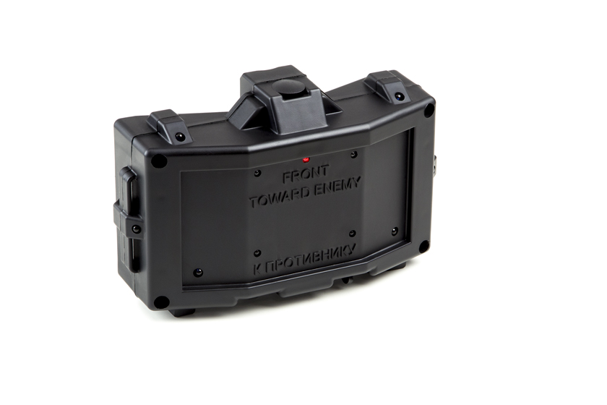

**CERBERUS mine**

**Additional Device**

Smolensk

It is necessary to store the equipment in a well-ventilated space at temperature from + 18°C to + 30°C and relative humidity of 45-65%.

**Store equipment only in charged state (ideally under nominal voltage conditions).**

1. **Guarantee commitment**

The manufacturer guarantees the reliability of the operation of an individual LASERWAR set if the consumer has complied with the conditions of use. The manufacturer undertakes to replace or repair an individual set of equipment free of charge, if the customer has complied with the rules for the device transportation, storage, operation and delivery of defective equipment to Smolensk City.

**The warranty is 14 days for batteries, speakers, and IR modules.**

**PLEASE NOTE! In the case of improper operation of the accumulator (charging by an unrelated type of a charger), the warranty doesn't cover the battery!**

You can see on our website a complete technical maintenance manual for Lasertag equipment: **www.cybertag.ru**.

1. **Operating rules**

***1. Weather conditions.*** We strongly recommend that the equipment shouldn’t be used in the rain and at temperatures below -20 ° C.

Avoid getting moisture inside the device. If this happened, turn off the device, dry the equipment at room temperature for at least two hours.

Having used the device at low temperatures don't try to charge it immediately after the game. Wait for electronics to warm up.

***2. Batteries.*** The device has lithium batteries. To recharge the device use only universal Li+ chargers.

**Connect the charger to the device, and only then to the netwok.**

**Please note!** During charging the power button should be off.

You can control the recharge process with the help of a special indicator. If the battery is low, the LED is red; When the recharge process is complete, the color will be changed to green.

6

7

1. **Description and work**
   1. **Device**

The laser tag game set MINE consists of two parts, a mine and a plug-key.

The plug-key is a special closed-contact device you can use to configure your equipment. It is inserted into the charging socket.

The MINE game set parts are presented on the Diagram No. 1.

*Diagram No. 1*

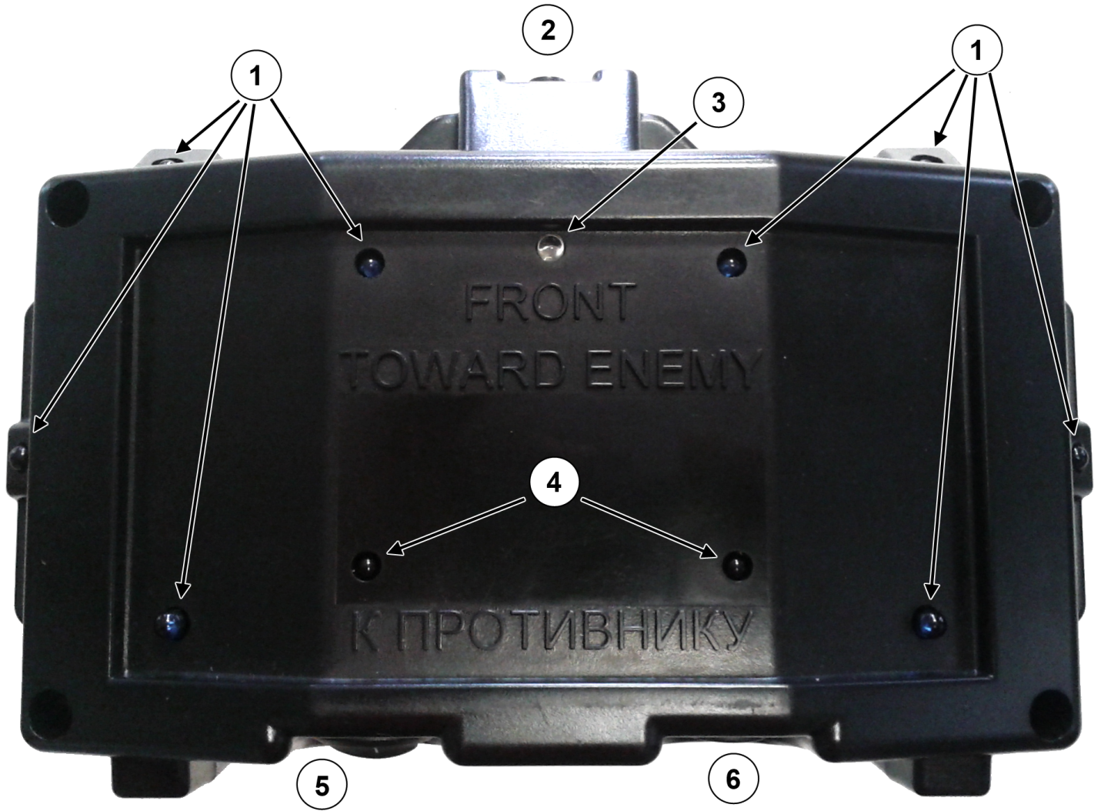

1— IR LEDs

2 — Slot for fuse installation/plug

3 — Red LED

1— IR sensors

5 — Power switch

6 — charging socket

Information on the repairs performed during the maintenance period (completed by the Service centre performing the warranty repair works).

|  |  |
| --- | --- |
| **Date**: __________________  **Completed work:** _____________________________________________________________________  **Service centre stamp** | **Date**: __________________  **Completed work:** _____________________________________________________________________  **Service centre stamp** |
| **Date**: __________________  **Completed work:** _____________________________________________________________________  **Service centre stamp** | **Date**: __________________  **Completed work:** _____________________________________________________________________  **Service centre stamp** |
| **Date**: __________________  **Completed work:** _____________________________________________________________________  **Service centre stamp** | **Date**: __________________  **Completed work:** _____________________________________________________________________  **Service centre stamp** |

3

10

* 1. **Changing the performance characteristics**

Changing the performance characteristics is realized manually with the help of the Nano remote control and plug-key (inserted into the charging socket).

When entering this mode, you will hear the following sound: "Settings mode", and the red LED will start blinking. Use the Nano remote control to change settings: The small button selects an option and the big one changes its parameters. After all the parameters have been set, you must wait five seconds for them to be set. The mine will save your settings. You will also hear a short beep.

To exit the configuration mode, turn off and turn on the device.

Settings info:

**— Sounds**.  ***Minimum****.* Low sounds will not attract your enemy's attention. The battery charge is saved. ***All***. Understandable voice messages. Attractive for casual players.

**— Detonation.** ***Explosion.*** The absolute illumination of all nearby players regardless of their color. ***— Shot.*** The mine produces a series of shots making a maximum damage.

**— Mode**. ***Classic.*** If you turn the power on, the mine will be immediately activated. ***Advanced.*** After each explosion, you need to activate the mine with the "New Game command." You won't be able to use the device indefinitely, constantly switching it on/off. The principle is as follows: One activation — one explosion.

**— Motion sensor**. ***Turned off.*** Saves the battery charge. Prevents accidental activations. ***Turned on.*** Allows you not to install the trip wire. Saves time you need to install the mine.

**Warranty Terms:**

1. The guarantee is effective upon presentation of the present certificate, which indicates the purchase date of the equipment confirmed by the service centre.

2. These guarantee obligations apply to products acquired only from the official LASERTAG representative or the official dealer.

3. The present guarantee is invalid if the product deficiencies have occurred in the following cases:

- failure to comply with Operating instructions;

- mechanical damage;

- penetration of extraneous items, liquids, etc.;

- animal activities;

- unauthorized access to the parts of the game set by non-authorized persons;

- use of the product for purposes for which it hasn't been made;

- Acts of elements (natural disaster, fire, accidents, etc.);

- the game set malfunction in case of faulty power network and/or poor care of the product.

4. If the warranty certificate is lost, no duplicate is issued.

4

9

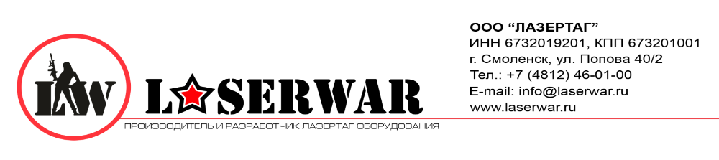

Dear Customer!

Our company welcomes and thanks you for the decision to buy our products, and is confident that the purchased device will bring you a long-term pleasure. The warranty certificate establishes the guarantee of the product in the amount provided for by the Law on consumer protection of the Russian Federation.

This warranty certificate is valid for **12 months** from the purchase date of the product, and is subject to the guarantee terms.

* 1. **Pre-starting procedure**

To activate the Mine game set you must turn on device. Then you will hear a beep. If the *classic mode* is selected the 5-second countdown starts. There will be short signals. The diode on the front panel will light up. When the countdown ends, the mine will be cocked.

The detonation of a mine can be carried out in two ways:

**The infrared motion sensor activation** It's very convenient: it does not require the string to be pulled but has a limited range (about 3 meters).

**Detonation.** The mine can detonate if another mine or a grenade explodes.  
The mine can also be detonated if somebody shoots at it. By default, the mine has 100 HP, and a shot from any weapon will damage it. When HP falls below zero, the mine explodes.

Use the settings to select the way in which the mine strikes the players.

— "Blast" is a special command of the IR protocol. The blast instantly kills all the nearby players, regardless of their color.

— "Shoot" — The mine produces a series of shots making a maximum damage.

When detonated the device beeps periodically for 10 minutes. The red diode on the front panel will light up. When ten minutes have elapsed, the device turns off.

8

5

Purchase Date: _______________

1. **Contact information**

Official website:

www.laserwar.ru

E-mail:

sale@laserwar.ru

support@laserwar.ru

Skype:

sale-laserwar.ru

support laserwar.ru



**_____________________**

*Stamp signature*

**Serial Number:**



1. **The intent of the device**

The Mine game set is an additional device designed to play laser tag.

1. **Technical Characteristics:**

|  |  |
| --- | --- |
| Weight | 0.580 kg |
| Length/width/height | 21/15/8 cm |
| Type of battery | Li +;  7.4 V; 2.2 AH |
| Battery charger Type | Automatic, Li + |
| Battery life | up to 36 hours |
| Blast radius | up to 12 m |

1. **Contents of delivery**

|  |  |  |  |
| --- | --- | --- | --- |
| **№**  **Ser. No.** | **Name** | **Unit of Measure** | **Amount** |
| 1. | MINE | pc. | 1 |
| 2. | Plug-key | pc. | 1 |
|  | Product passport | pc. | 1 |

11

2