

LIMITED

LIABILITY COMPANY

**LASERTAG**

SPECIFICATION

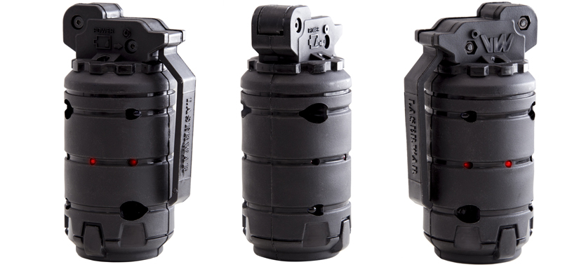

**Laser tag grenade**

**Trinity**

Smolensk

It is necessary to store the equipment in a well-ventilated space at temperature from + 18°C to + 30°C and relative humidity of 45-65%.

1. **Guarantee commitment**

The manufacturer guarantees the reliability of the operation of an individual LASERWAR set if the consumer has complied with the conditions of use. The manufacturer undertakes to replace or repair an individual set of equipment free of charge, if the customer has complied with the rules for the device transportation, storage, operation and delivery of defective equipment to Smolensk City.

The warranty for electronic parts is 12 months. In the case of mechanical damage to the frame or the electronic board, the warranty service is not performed.

You can see on our website a complete technical maintenance manual for Laser tag equipment: **www.cybertag.ru**.

1. **Operating rules**

***1. Weather conditions.*** We strongly recommend that the equipment shouldn’t be used in the rain and at temperatures below -20 °C.

Avoid getting moisture inside the device. If this happened, turn off the device, dry the equipment at room temperature for at least two hours.

Having used the device at low temperatures don't try to charge it immediately after the game. Wait for electronics to warm up.

***2. Batteries.*** Lithium AAA batteries are used as a power source in the game set. Replace the batteries in time to ensure the good work of the device.

6

7

1. **Description and work**
   1. **Device**

The grenade game set has a black plastic frame.

Inside the frame there are batteries, clamping elements. On the frame there are IR emitters.

The Trinity grenade game set is an additional device that can be used in different game scenarios. It imitates the work of a real grenade. When detonated, nearby players lose all health points.

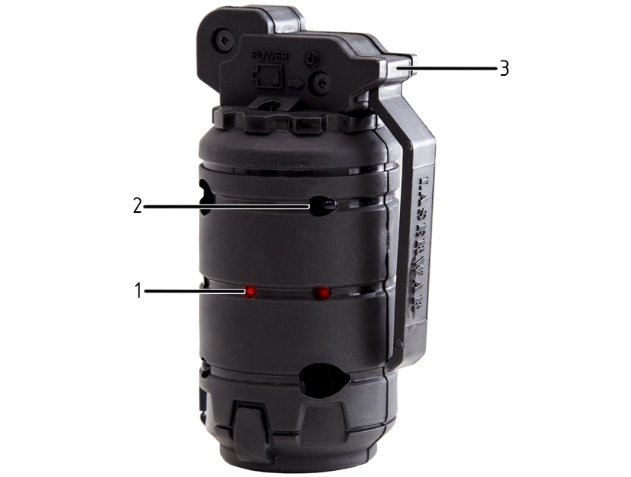

1. LEDs

2. IR-modules

3. Lever

Information on the repairs performed during the maintenance period (completed by the Service centre performing the warranty repair works).

|  |  |
| --- | --- |
| **Date**: __________________  **Completed work:** _____________________________________________________________________  **Service centre stamp** | **Date**: __________________  **Completed work:** _____________________________________________________________________  **Service centre stamp** |
| **Date**: __________________  **Completed work:** _____________________________________________________________________  **Service centre stamp** | **Date**: __________________  **Completed work:** _____________________________________________________________________  **Service centre stamp** |
| **Date**: __________________  **Completed work:** _____________________________________________________________________  **Service centre stamp** | **Date**: __________________  **Completed work:** _____________________________________________________________________  **Service centre stamp** |

3

10

* 1. **Changing the performance characteristics**

1. Slightly press the lever10 times. You'll hear a beep, and get to the time settings mode.
2. Set the time after which the grenade can be reused by pressing the lever.

1 LED flash — you can use a grenade immediately

2 LED flashes — use the grenade in 5 seconds

3 LED flashes — use the grenade in 60 seconds.

4 LED flashes — use the grenade in 300 seconds.

5 LED flashes — use the grenade in 600 seconds.

1. Press and hold the lever for 3 seconds to enter the command settings.
2. Choose required IR settings by pressing the lever.

1 sound signal – kill the player command.

2 sound signals – blow up a player command.

3 beeps — "stun" the player

1. Press and hold the lever to confirm.

**Warranty Terms:**

**1.** The guarantee is effective upon presentation of the present certificate, which indicates the purchase date of the equipment confirmed by the service centre.

**2.** These guarantee obligations apply to products acquired only from the official LASERTAG representative or the official dealer.

**3.** The present guarantee is invalid if the product deficiencies have occurred in the following cases:

- failure to comply with Operating instructions;

- mechanical damage;

- penetration of extraneous items, liquids, etc.;

- animal activities;

- unauthorized access to the parts of the game set by non-authorized persons;

- use of the product for purposes for which it hasn't been made;

- Acts of elements (natural disaster, fire, accidents, etc.);

- the game set malfunction in case of faulty power network and/or poor care of the product.

**4.** If the warranty certificate is lost, no duplicate is issued.

4

9



Dear Customer!

Our company welcomes and thanks you for the decision to buy our products, and is confident that the purchased device will bring you a long-term pleasure. The warranty certificate establishes the guarantee of the product in the amount provided for by the Law on consumer protection of the Russian Federation.

* 1. **Pre-starting procedure**

Turn on the device by pressing the lever.

The grenade activates a combat mode. The detonation countdown starts.

The indoor kill distance is 20 meters; the outdoor kill distance is 10 meters. The kill distance depends upon the batteries. Replace them in time to ensure a maximum kill distance.

We don't recommend that you throw the grenade up, or hit it hard on the ground, wall, wooden surface. Roll the grenade with an underhanded motion. In this case, the risk of damage is minimal. It will prolong the life of the device. In the case of a grenade failure due to mechanical damage, no warranty service is provided.

8

5

Purchase Date: _______________

1. **Contact information**

Official website:

www.laserwar.ru

E-mail:

info@laserwar.ru

support@laserwar.ru

Skype:

info-laserwar.ru

support laserwar.ru



**_____________________**

*Stamp signature*

1. **The intent of the device**

The Triniti grenade game set is an additional device designed to play laser tag.

1. **Technical Specifications**

|  |  |
| --- | --- |
| Weight | 0.14 kg |
| Height | 110 mm |
| Diameter | 55 mm |
| Number of IR-emitters | 6 |
| Power source type | 2 AA batteries |
| Battery life | 14 days |

1. **Contents of delivery**

|  |  |  |  |
| --- | --- | --- | --- |
| **№**  **Ser. No.** | **Name** | **Unit of Measure** | **Amount** |
| 1. | Grenade | pc. | 1 |
| 2. | Specification | pc. | 1 |

11

2